**PART OF ZOHO LEVEL 2 RECRUITMENT**

**Software Requirements**

* Xampp
* Atom IDE/VS code
* Any browser(preferably chrome)

**Steps to execute program**

**STEP 1:**

* Download the entire contact management folder
* Copy the entire folder and paste/save in the following location(d:\xampp\htdocs)

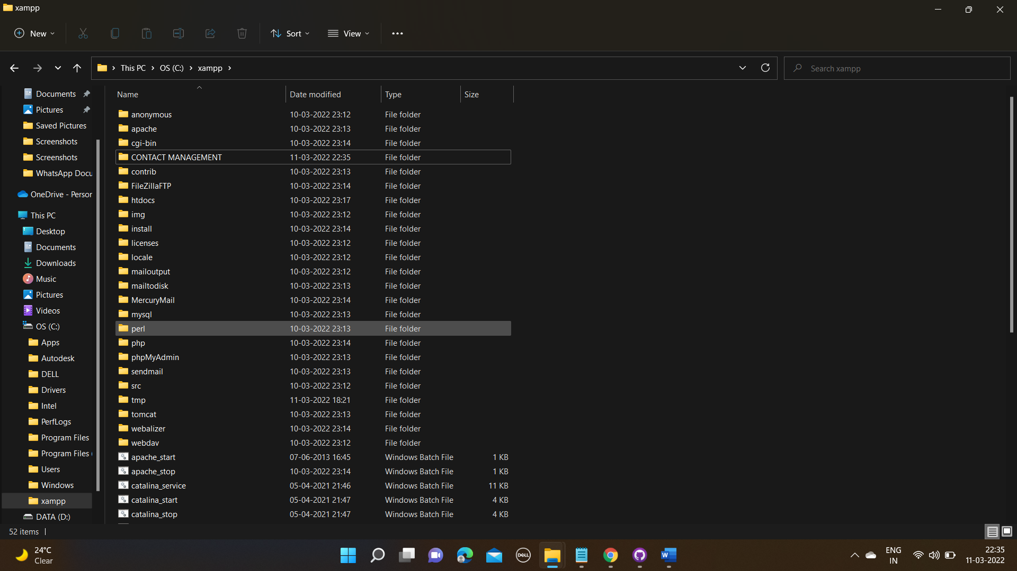

* Now power on the xampp server i.e. installed in your system

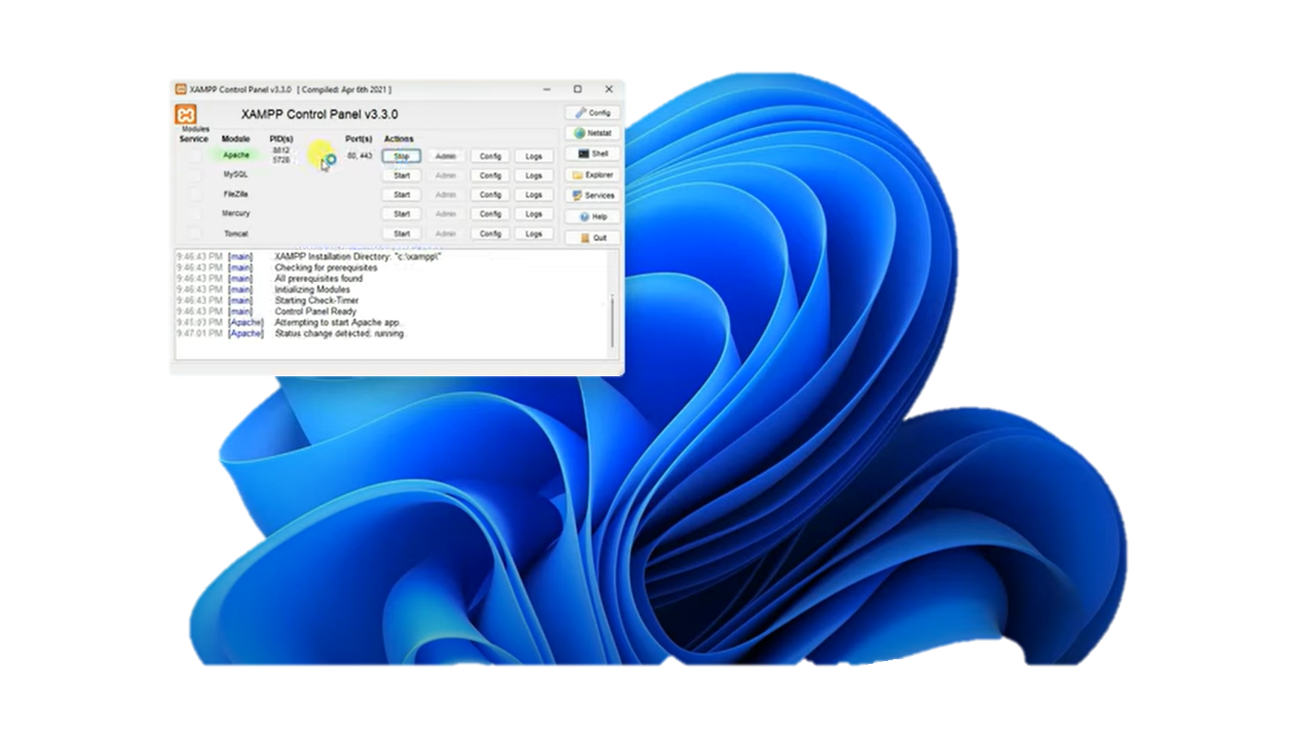

* Now click on admin,to get on t the backend after click on it,you will find the following details on page

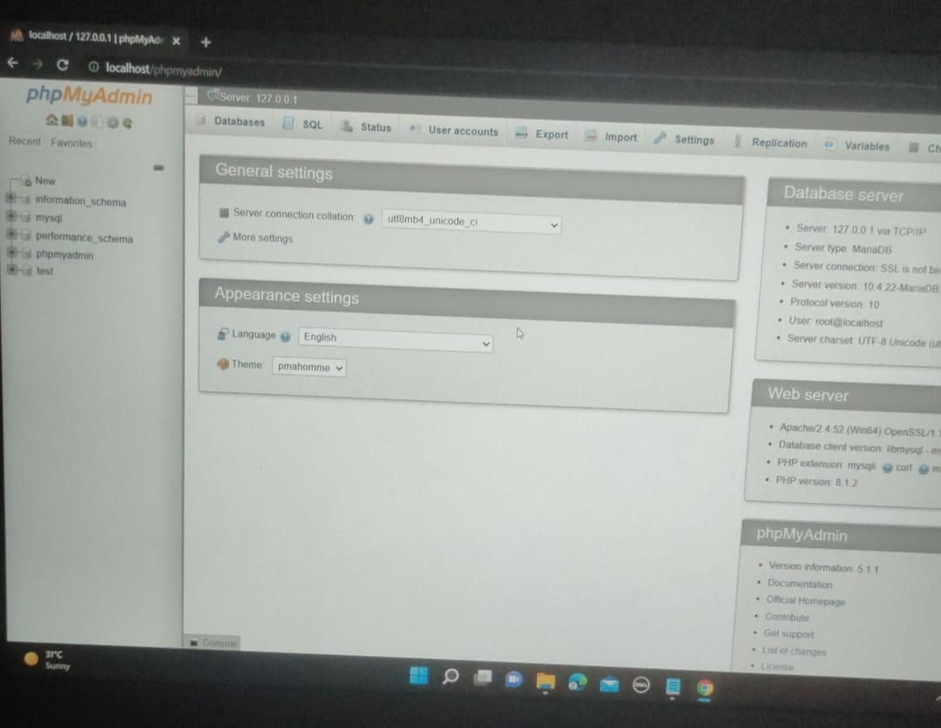

* Now click on the new and create a database “contact app”

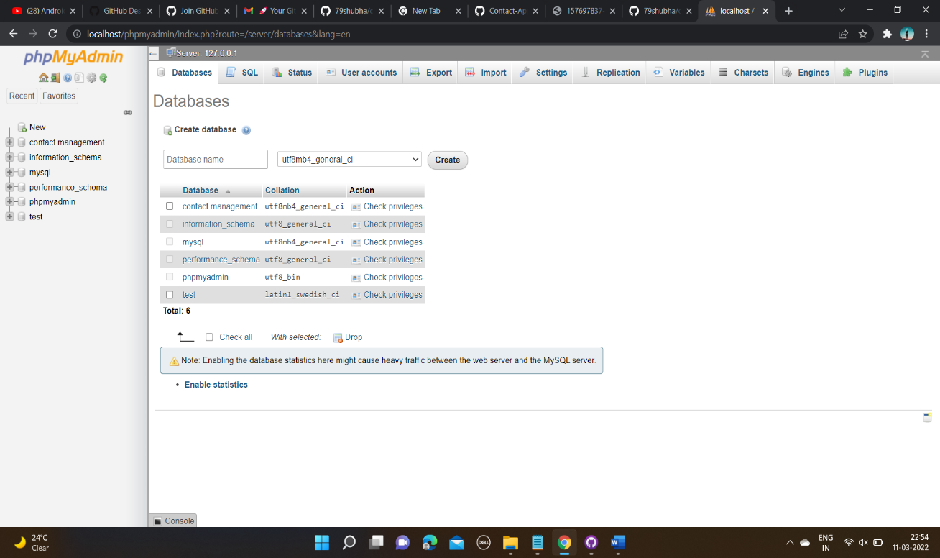

* Now after creating database click on import and choose file from location

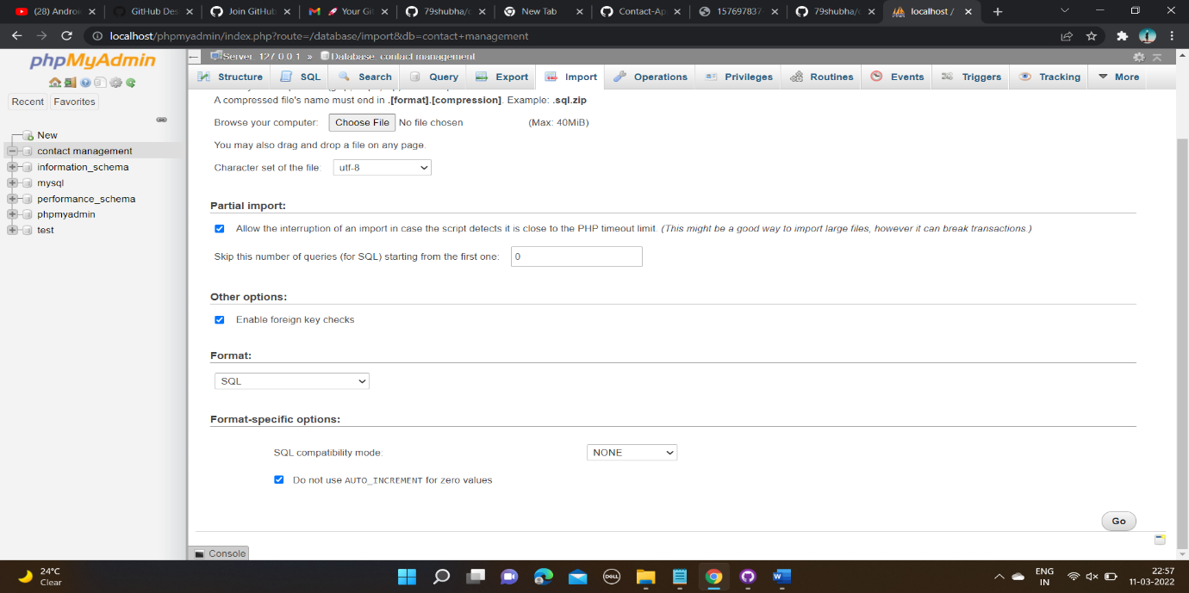

**STEP 2 :**

* **Now in step 2 you have to open browser:**
* **Type;**

**“localhost/contactmanagement”**

**And press enter**

* **Then you will be redirected to the following page:signin/home page (before sign in)**

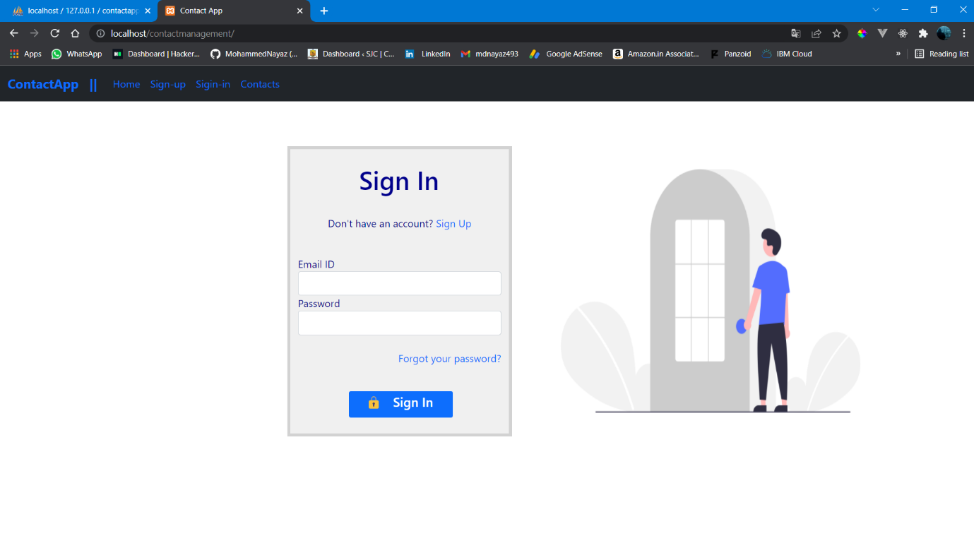

* Then application is ready to use
* Then sign up page

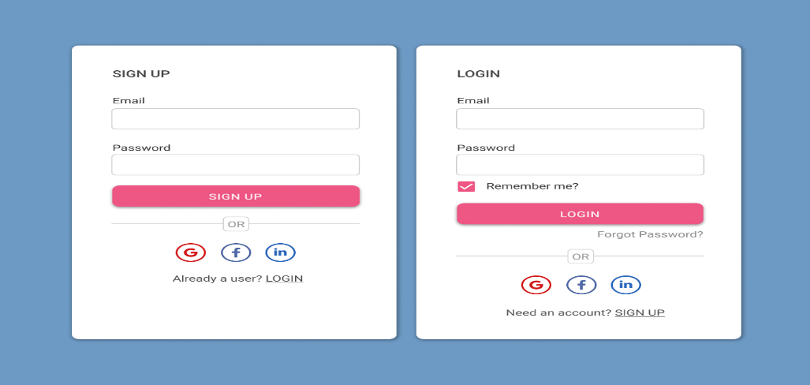

* Trying to access page before logging



* Contact page after signing in

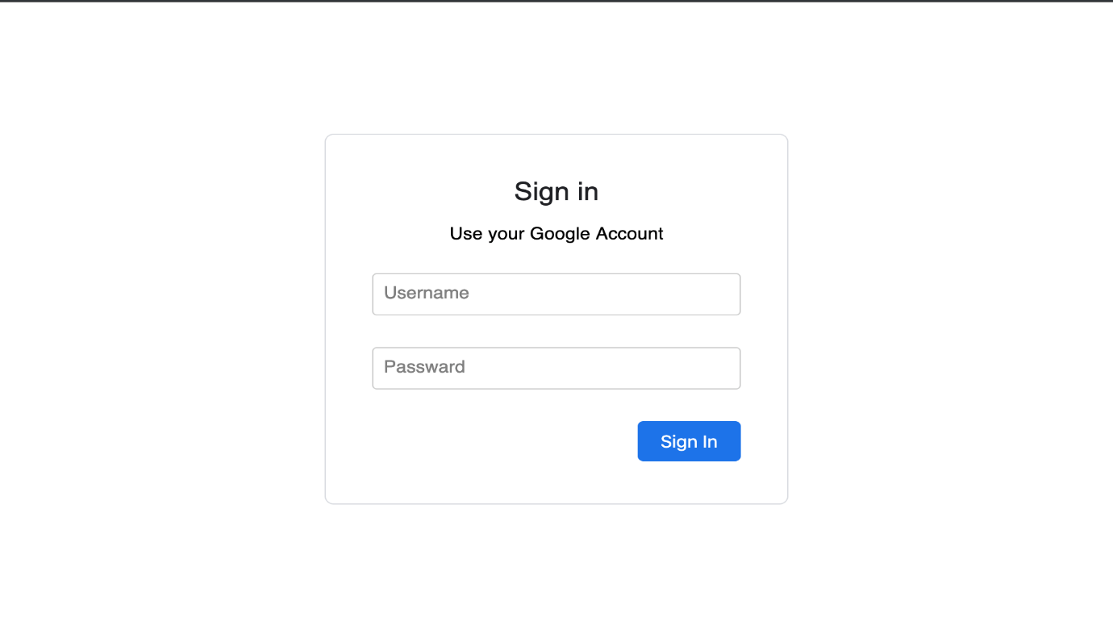

* HOME PAGE POST SIGNING IN

**STEP 3 :**

* **REFERENCE:https://github.com/79shubha/contact-management.git**